2024 VCE VET Engineering Studies external assessment report

General comments
The 2024 VCE VET Engineering Studies written examination covered content from the following units of competency:
- MEMPE006A Undertake a basic engineering project
- VU22333 Perform intermediate engineering computations.
Overall, safety and calculations were strong areas in student responses in the 2024 examination. However, calculations used in responses could be further improved with a greater focus on showing a logical sequence of workings. Some responses presented their calculations in a scattered manner, making them difficult to follow. Doing so not only increases the risk of mistakes being made but also complicates the allocation of marks if the final answer is incorrect.
A key area for improvement is the use of correct terminology. Basic tools, such as the tap wrench, punch and tin snips, were often named incorrectly or not named at all. Similarly, terminology for drawing items was not used well, with a high number of responses incorrectly identifying items such as a chamfer and datum lines.
Students should carefully read questions and be guided by the provided information when formulating responses. Many students appeared to overlook critical information. For instance, in Question 25d., the provided dot points highlighted key details that were required in responses, but often these were not included.
Third-angle projection is an area that requires further attention. Students need to understand that the relationships between the three views are just as important as the views themselves for accurate representation in third-angle projection. In addition, very few responses demonstrated the ability to draw a basic section view, with many instead drawing simple sketches of a plan view.
Another area for improvement is operational planning. Basic errors were made in Question 11a., such as bending the cladding before cutting the cladding to size.
Bearing-related questions were not answered well. Plain and anti-friction bearings are part of the main unit of competency MEMPE006A, but very few responses demonstrated adequate knowledge in this area.

Specific information
This report provides sample answers, or an indication of what answers may have been included. Unless otherwise stated, these are not intended to be exemplary or complete responses.
The statistics in this report may be subject to rounding resulting in a total more or less than 100 per cent.
The examination consisted of short-answer and extended-answer questions that included multiple parts.

Question 1
Mark | 0 | 1 | Average
% | 58 | 42 | 0.4
Typical acceptable answers included:
- job is secure
- chuck key not left in chuck
- material not sticking out too far from chuck
- guard in place
- no loose tools on headstock.
This question was answered well by the majority of students.

Question 2
Mark | 0 | 1 | 2 | 3 | Average
% | 7 | 23 | 42 | 28 | 1.9

Items and description of movement | Mechanical aid / equipment
moving a 1 m³ wooden crate containing steel components weighing 150 kg to a storage facility | forklift  pallet jack
moving a box weighing 25 kg a distance of 10 m | trolley  sack truck
lifting a large vice onto a milling machine | hoist  hydraulic lift table  small crane
This question was answered well by the majority of students. Some responses mentioned a two-person lift, which was not acceptable, as the question stated ‘manual handling is not considered a safe option’. Students are reminded to carefully read the question.
Some responses interpreted moving the wooden crate to a storage facility as an external storage facility, and so included the use of a truck. While this interpretation was not the intent of the question, students were not penalised for putting ‘truck’ as an answer.

Question 3
Mark | 0 | 1 | 2 | 3 | 4 | 5 | 6 | Average
% | 5 | 8 | 13 | 14 | 26 | 23 | 11 | 3.6

Typical acceptable answers included:
Sign | Description | Meaning | Example
 | red circle with red diagonal line over a diagram | - prohibition  - don’t do this  - stop | - No naked flames  - Do not enter
 | blue circle with a diagram inside the circle | - mandatory  - you must do this | - Eye protection must be worn in this area  - Wash your hands
 | green square or rectangle with diagram inside the square | - safety information  - first aid signs  - escape route | - First aid station  - Emergency exit
A common error in responses was repeating the same answer for ‘meaning’ and ‘example’.

Question 4
Mark | 0 | 1 | 2 | Average
% | 17 | 45 | 38 | 1.2
Acceptable answers included:
- compare weight
- compare colour
- use magnet.
Most students answered this question well. Some answers that were not accepted included seeing which one rusts, or cutting with a hacksaw to see which one is softer. While there is some truth in these answers, they were not considered practical in the context of the question.

Question 5
Mark | 0 | 1 | 2 | 3 | 4 | 5 | 6 | Average
% | 6 | 2 | 15 | 5 | 26 | 7 | 39 | 4.2
Typical acceptable answers included:
Item | Material | Reason
kitchen sink | stainless steel, ceramic | will not rust / hygienic
frame of a rack to hold sheet metal | mild steel | strong / cheap / easily welded
portable step ladder | aluminium | lightweight / easy fabrication due to variety of shapes available
Some responses gave appropriate reasons for incorrect materials; in such cases, students were awarded one mark for the correct reason but not for the incorrect material.

Question 6
Mark | 0 | 1 | 2 | 3 | 4 | Average
% | 3 | 11 | 22 | 40 | 23 | 2.7
Acceptable answers were:
Dimension | Measuring tool
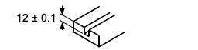 | Vernier caliper  depth micrometer
 | protractor
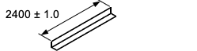 | tape measure
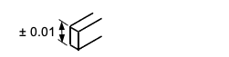 | micrometer  Vernier caliper
Some responses did not consider the specified tolerance and sizes, resulting in an incorrect tool being selected. Another common error was choosing a rule to measure the 2400 length rather than a tape measure.

Question 7a.
Mark | 0 | 1 | Average
% | 66 | 34 | 0.4
Acceptable answers were:
- split pin
- cotter pin.
A large number of responses did not provide the correct name of the fastener.

Question 7b.
Mark | 0 | 1 | Average
% | 86 | 14 | 0.2
Acceptable answers were:
- castellated nut
- washer.
Few responses demonstrated understanding of the use/application of a split pin.

Question 8
Mark | 0 | 1 | 2 | 3 | 4 | 5 | Average
% | 4 | 5 | 13 | 23 | 28 | 26 | 3.4
Solution:

Few responses received full marks for this question. Most had some or all of the three views correct; however, the biggest issue was the correct relationship between the views for correct third-angle projection. Another issue was the inaccurate sketching of centre lines and broken lines.

Question 9
Mark | 0 | 1 | 2 | 3 | 4 | Average
% | 1 | 1 | 8 | 29 | 60 | 3.5
Solution:
Material | Letter
25 × 25 angle iron | F
20 × 50 rectangular hollow section (RHS) | J
20 × 40 channel | B
25 × 25 solid bar | I
This question was answered well by the vast majority of students.

Question 10
Mark | 0 | 1 | 2 | 3 | 4 | Average
% | 12 | 26 | 29 | 20 | 13 | 2.0
Solution:
Task | Letter | Name of tool
cutting sheet metal | B | tin snips /  aviation shears
removing an 8 mm diameter pin from a hole | J | pin punch /  punch
gripping a 25 mm diameter pipe | H | multigrips /  slip joint pliers /  adjustable pliers
undoing a nut in a recessed location | E | socket
Most responses identified the correct tool to use by its letter but could not correctly name the tool.

Question 11a.
Mark | 0 | 1 | 2 | 3 | Average
% | 5 | 35 | 12 | 48 | 2.1
Solution:
Step | Sequence
Cut SHS to length. | 1
Check and square up frame. | 3
Measure size of cladding on frame. | 5
Cut sheet metal cladding to size. | 6
Finish weld SHS frame. | 4
Bend cladding. | 7
Tack weld SHS frame. | 2
Fit sheet metal cladding. | 8
Responses often suggested an illogical sequencing of jobs. The most common errors were cutting the cladding before measuring the cladding size. Also common was tack welding, measuring and cutting cladding, then returning to finish weld frame. While this is possible, there is no logical reason to leave the welding and come back to it.

Question 11b.
Mark | 0 | 1 | Average
% | 54 | 46 | 0.5
Solution:
- pop rivets
- self-tapping screws
- tek screws.
This question was answered correctly by the majority of students.

Question 12
Mark | 0 | 1 | 2 | 3 | Average
% | 47 | 23 | 17 | 13 | 1.0
Solution:
Task | Tool(s) required
turning diameters | turning tool (or similar)
producing thread | die and stock /  screw-cutting tool
cutting completed component from the steel bar | parting tool
Similar to other terminology questions, few responses stated the correct name of tools required.

Question 13a.
Mark | 0 | 1 | Average
% | 37 | 63 | 0.7
Solution:
X = 140 – 30
X = 110
This question was answered correctly by the majority of students. Some responses, however, used trigonometry to solve the question, which was not necessary as the height of the triangle was also 30 due to the 45-degree angle.

Question 13b.
Mark | 0 | 1 | 2 | 3 | Average
% | 25 | 13 | 7 | 55 | 1.9
Solution:
110
42
Y
Tan Y = 42 / 110
Tan Y = 0.3818
Y = 20.8968
Y = 20.9°

Question 14a.
Mark | 0 | 1 | Average
% | 15 | 85 | 0.9
8.5 mm.
This question was answered well by the majority of students.

Question 14b(i).
Mark | 0 | 1 | Average
% | 33 | 67 | 0.7
14 mm.
Overall, this question was answered well, although some responses did not relate to the slot size shown on the drawing.

Question 14b(ii).
Mark | 0 | 1 | Average
% | 32 | 68 | 0.7
RPM = 320 × 30 / 14
RPM = 686
This question was answered well by the majority of students.

Question 14c.
Mark | 0 | 1 | Average
% | 29 | 71 | 0.7
Typical acceptable answers included:
- broken cutter
- blunt cutter
- tool or metal overheating
- material coming out
- chattering / poor finish.
This question was answered well by the majority of students.

Question 14d.
Mark | 0 | 1 | Average
% | 72 | 28 | 0.3
Accurate size hole.
This question was answered well overall. Some responses, however, indicated that students may not know what a reamer is.

Question 15
Mark | 0 | 1 | 2 | Average
% | 88 | 8 | 5 | 0.2
A: Radial
B: Axial or Thrust.
This question was not answered well. The majority of responses demonstrated a significant lack of bearing-related knowledge.

Question 16
Mark | 0 | 1 | 2 | 3 | 4 | Average
% | 3 | 2 | 8 | 11 | 77 | 3.6

Imperial size | Metric size
5” | 127.00
3½” | 88.90
Ø ¾” | 19.05
5/8” | 15.88
This question was answered well by the majority of students.

Question 17a.
Mark | 0 | 1 | Average
% | 53 | 47 | 0.5
Chamfer.
A high number of incorrect responses indicated students were not familiar with basic drawing terminology, such as ‘chamfer’.

Question 17b.
Mark | 0 | 1 | Average
% | 61 | 39 | 0.4
Radius.
A high number of incorrect responses indicated students were not familiar with basic drawing terminology, such as ‘radius’.

Question 17c.
Mark | 0 | 1 | Average
% | 80 | 20 | 0.2
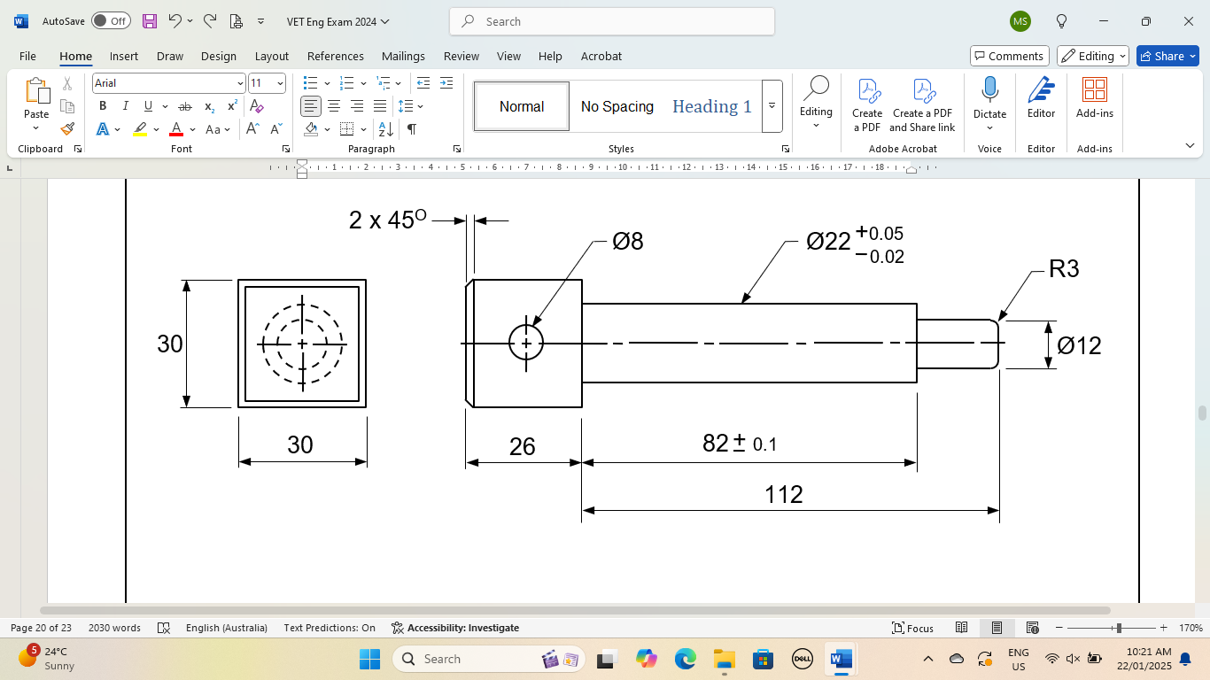
Datum

This question was not answered well. A large number of responses pointed to the centre line as the datum.

Question 17d.
Mark | 0 | 1 | Average
% | 79 | 21 | 0.2
Typical acceptable responses included:
- eliminate cumulative error
- more accurate dimensions
- reference point for dimensions.
The majority of responses did not answer this question correctly, suggesting students were not familiar with datums on drawings.

Question 17e.
Mark | 0 | 1 | Average
% | 34 | 66 | 0.7
Four-jaw chuck.
This question was not answered well, highlighting that students may not be adequately familiar with the correct terminology.

Question 17f.
Mark | 0 | 1 | 2 | Average
% | 29 | 52 | 19 | 0.9

Dimension | Maximum | Minimum
112 length | 112.50 | 111.50
Ø22 | 22.05 | 21.98
Basic errors were made in some responses, such as mixing up the maximum and minimums.

Question 18a.
Mark | 0 | 1 | Average
% | 27 | 73 | 0.7
Typical acceptable responses included:
- easy to disassemble if required
- less skill required
- more suitable for mixed materials that may be difficult / not able to be welded.

Question 18b.
Mark | 0 | 1 | 2 | Average
% | 15 | 35 | 49 | 1.4
Typical acceptable responses included the following.
Advantage:
- faster/easier to apply
- can bind different materials
- less weight.
Disadvantage:
- can lose strength over time
- difficult to disassemble.
The majority of students answered well for both advantage and disadvantage.

Question 19a(i).
Mark | 0 | 1 | Average
% | 27 | 73 | 0.8
A.
This question was answered correctly by the majority of students.

Question 19a(ii).
Mark | 0 | 1 | Average
% | 60 | 40 | 0.4
Acceptable responses:
- Full thread will go deeper into blind hole (or similar).
- Has threads all the way down the tap.
Some responses were unable to explain the reason relating to the threads at the front of the tap.

Question 19b.
Mark | 0 | 1 | Average
% | 78 | 22 | 0.3
Tap wrench.
Very few responses identified this tool by its correct name.

Question 20
Mark | 0 | 1 | 2 | 3 | 4 | Average
% | 27 | 29 | 25 | 13 | 7 | 1.5

Tool | Common use(s)
parallel strips | lift job in vice / position job parallel in vice
centre drill | drill hole for lathe centre / provide starting point for drill
drill drift | remove taper sleeves / remove chuck from drill spindle
Vernier height gauge | marking out / taking vertical measurements
Most responses correctly identified the centre drill but could not identify the other tools, particularly parallel strips and the drill drift.

Question 21a.
Mark | 0 | 1 | Average
% | 19 | 81 | 0.8
Produce engineering drawings / design projects.
This question was answered well by the majority of students.

Question 21b.
Mark | 0 | 1 | 2 | Average
% | 6 | 31 | 63 | 1.6
Typical acceptable responses included the following.
Advantage:
- faster / more productive
- easy to edit
- can do 3D modelling
- accuracy
- easy to share files.
Disadvantage:
- hard to use / requires training
- files can be lost
- cost of software.
Overall, this question was answered well, demonstrating that students had a good understanding of CAD.

Question 22a.
Mark | 0 | 1 | Average
% | 82 | 18 | 0.2
Dial indicator / clock gauge.

Question 22b.
Mark | 0 | 1 | Average
% | 74 | 26 | 0.3
Typical acceptable responses included:
- setting up work in lathe
- aligning vice on milling machine.
Most responses indicated students were not familiar with a dial indicator.

Question 23a.
Mark | 0 | 1 | Average
% | 40 | 60 | 0.6
Circumference = πD
3.142 × 1200
3770 mm
This question was answered well by the majority of students.

Question 23b.
Mark | 0 | 1 | 2 | Average
% | 51 | 13 | 36 | 0.9

V = πr² × H
V = 3.142 × 0.6² × 2.0
V = 1.13 × 2
V = 2.26 m³

A common mistake was not using the correct formula for volume.

Question 23c.
Mark | 0 | 1 | 2 | Average
% | 51 | 17 | 32 | 0.8

V = πr² × H
V = 3.142 × 0.6² × 2.0
V = 1.13 × 2
V = 2.26 m³

A common mistake was calculating the percentage of the remaining product rather than the used product.

Question 24
Mark | 0 | 1 | 2 | 3 | Average
% | 60 | 23 | 7 | 9 | 0.7

Section A-A

The majority of responses demonstrated that students were not familiar with a section view. Showing a plan view was a common response.

Question 25a.
Mark | 0 | 1 | 2 | 3 | Average
% | 45 | 24 | 17 | 15 | 1.0

A common error was not subtracting the size of the SHS – that is, using 1200 and 600 lengths for calculating the angled pieces.

Question 25b.
Mark | 0 | 1 | 2 | Average
% | 27 | 23 | 50 | 1.2
1.2 × 1.8 = 2.16
2.16 × 2 = 4.32 m²

A common error was calculating only one side of the gate, not front and back as stated in the question.

Question 25c.
Mark | 0 | 1 | 2 | Average
% | 14 | 69 | 18 | 1.1
- use a square to check corners
- compare diagonal measurements.
Most responses listed one method but did not give a second.

Question 25d.
Mark | 0 | 1 | 2 | 3 | 4 | Average
% | 34 | 21 | 18 | 19 | 8 | 1.5
Sample answer:
4 holes tapped M6
Steel plate – 5 mm thick
50
Design notes:
- Plate welded to tube
- Plate face flush with front of tube
- M6 screws used to attached padbolt

Other common acceptable designs included using two pieces of SHS welded in and using self-tapping screws or pop rivets to fasten the padbolt.
Students are reminded to pay careful attention to the details required, as stated in the question.

Common design errors were:
- material not being flush with front
- using nuts and bolts going through from front to back (not ideal)
- using material too narrow for the padbolt to sit on (minimum 40 mm required).

