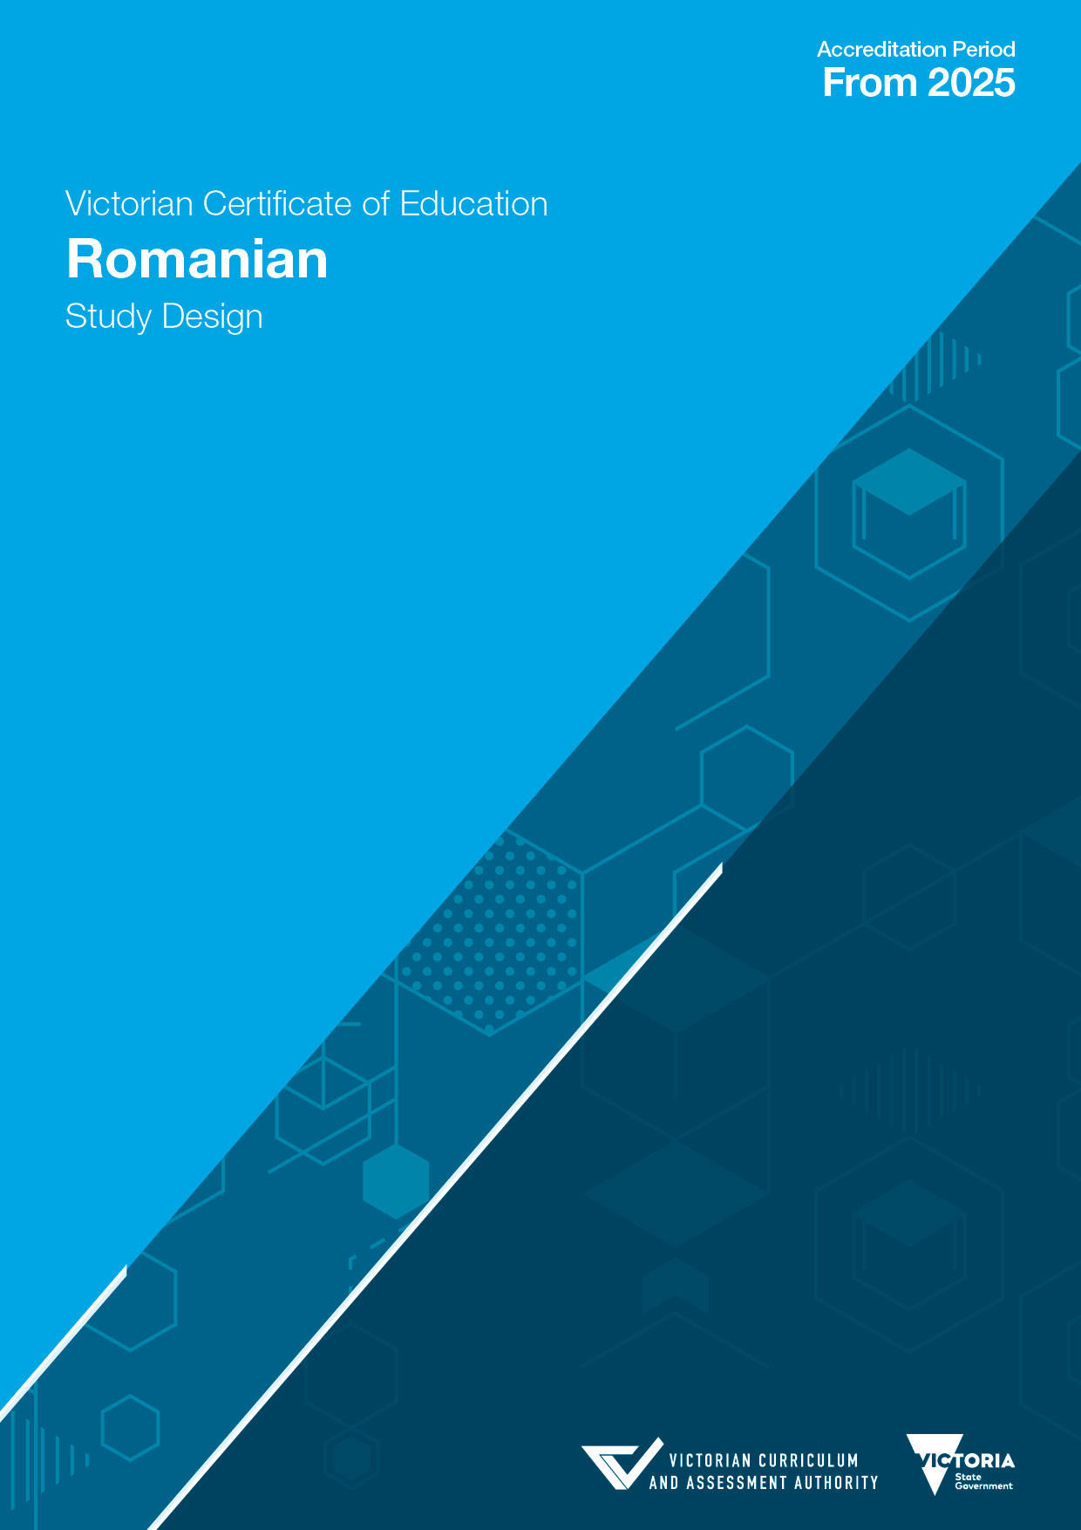

Collaborative Curriculum and Assessment Framework for Languages (CCAFL)
Romanian

The CCAFL Framework (2021) has been compiled by the Victorian Curriculum and Assessment Authority and developed collaboratively by the CCAFL Framework Renewal Project Working Party. The following agencies have contributed to this document:
Department of Education Tasmania
New South Wales Education Standards Authority
Northern Territory Department of Education
Queensland Curriculum and Assessment Authority
Office of Tasmanian Assessment, Standards and Certification
School Curriculum and Standards Authority, Western Australia
SACE Board of South Australia
Victorian Curriculum and Assessment Authority

The CCAFL Framework is only for use by agencies participating in the CCAFL Project in the development of senior secondary studies, syllabuses or courses for languages. For all other uses, please contact the CCAFL National Coordinator via the relevant participating agency.

Authorised and published by the Victorian Curriculum and Assessment Authority
Level 7, 2 Lonsdale Street
Melbourne VIC 3000
ISBN: 978-1-923025-18-9
© Victorian Curriculum and Assessment Authority 2022

No part of this publication may be reproduced except as specified under the Copyright Act 1968 or by permission from the VCAA. Excepting third-party elements, schools may use this resource in accordance with the VCAA educational allowance. For more information read the VCAA copyright policy.
The VCAA provides the only official, up-to-date versions of VCAA publications. Details of updates can be found on the VCAA website.
This publication may contain copyright material belonging to a third party. Every effort has been made to contact all copyright owners. If you believe that material in this publication is an infringement of your copyright, please email the Copyright Officer.
Copyright in materials appearing at any sites linked to this document rests with the copyright owner(s) of those materials, subject to the Copyright Act. The VCAA recommends you refer to copyright statements at linked sites before using such materials.
The VCAA logo is a registered trademark of the Victorian Curriculum and Assessment Authority.

Contact us if you need this information in an accessible format; for example, large print or audio.
Telephone (03) 9032 1635 or email vcaa.media.publications@education.vic.gov.au

Contents
Important information 5
Purposes of the CCAFL Framework 6
Introduction 7
Scope of study 7
Language 7
Rationale 7
Aims 8
Objectives 8
Structure 8
Entry 9
Duration 9
Changes to the study design 9
Monitoring for quality 9
Safety and wellbeing 9
Employability skills 9
Legislative compliance 10
Child Safe Standards 10
Assessment and reporting 11
Satisfactory completion 11
Levels of achievement 11
Authentication 12
Study specifications 13
Learning language 14
Communication skills 14
Language and culture 14
Language as a system 15
Vocabulary 15
Grammar 15
Language functions 16
Language structures 16
Text types 21
Writing styles 21
Dictionaries 22

Using language 23
Content 23
Concepts 23
Perspectives 24
Topics 24
Task design 26
Tasks 26
Terms used in the study 27
Unit 1 29
Area of Study 1 29
Area of Study 2 30
Area of Study 3 30
Assessment 31
Unit 2 33
Area of Study 1 33
Area of Study 2 33
Area of Study 3 34
Assessment 35
Unit 3 37
Area of Study 1 37
Area of Study 2 38
Area of Study 3 38
School-based assessment 39
External assessment 40
Unit 4 41
Area of Study 1 41
Area of Study 2 42
Area of Study 3 43
School-based assessment 43
External assessment 44

Important information

Accreditation period
Implementation for Units 1 and 2 of this study commences in 2024.
Implementation for Units 3 and 4 of this study commences in 2025.

Other sources of information
The VCAA Bulletin is the only official source of changes to regulations and accredited studies. The Bulletin also regularly includes advice on VCE studies. It is the responsibility of each VCE teacher to refer to each issue of the Bulletin. The Bulletin is available as an e-newsletter via free subscription on the VCAA website.
To assist teachers in developing courses, the VCAA publishes online Support materials (incorporating the previously known Advice for teachers).
The current VCE Administrative Handbook contains essential information on assessment processes and other procedures.

VCE providers
Throughout this study design the term ‘school’ is intended to include both schools and other VCE providers.

Copyright
Schools may use this VCE study design in accordance with the VCAA educational allowance, including making copies for students and use within the school’s secure online teaching and learning environment.
For details, access the full VCAA copyright policy on the VCAA website.

Purposes of the CCAFL Framework
The study of Romanian at senior secondary level is based on a common framework developed within the Collaborative Curriculum and Assessment Framework for Languages (CCAFL). The CCAFL Framework (2021) has been designed to:
- provide high quality, equitable and inclusive language curriculum and assessment for all students
- value prior language learning
- provide challenges and opportunities through learning and using new language
- emphasise effective communication and intercultural competence.
To achieve these purposes, the CCAFL Framework has the following organising features.
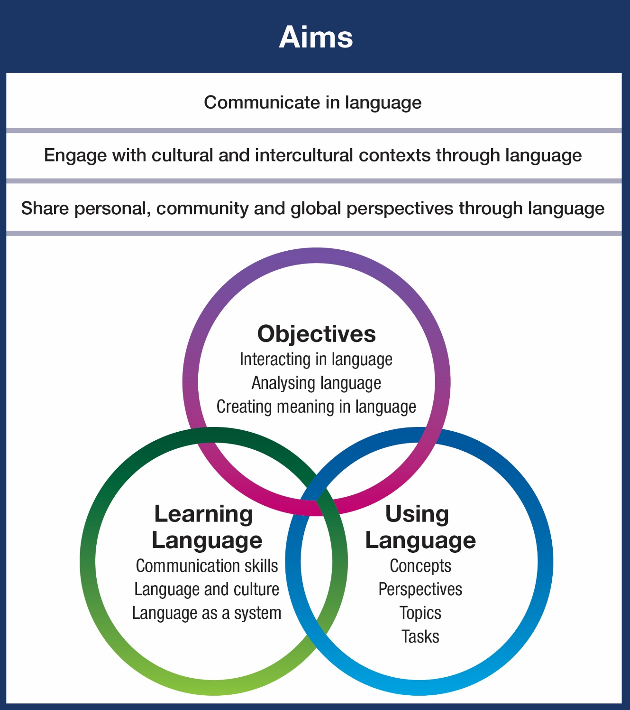

Introduction

Scope of study
VCE Romanian focuses on student participation in learning language and using language to interact with others, analyse language and create meaning in language. Learning language and using language require students to engage with the range of perspectives and topics related to the concepts that are a feature of the CCAFL Framework.
Students develop and extend skills in listening, speaking, reading, writing and viewing in Romanian in a range of contexts. They develop cultural and intercultural understanding, including skills to mediate between Romanian-speaking communities and the Australian social context.
Students develop their understanding of the relationships between language and culture in new contexts and consider how these relationships shape communities. Throughout the study students are given opportunities to make connections and comparisons based on personal reflections about the role of language and culture in communication and in personal identity.

Language
The language to be studied and assessed is the modern standard version of Romanian, in both spoken and written forms. Some variations in pronunciation and accent are acceptable. Students should be familiar with formal and informal language as prescribed in this study design.
The Romanian language has five main variants, each of which is distinguished primarily by phonetic and lexical differences that stem from the historical province in Romania where each originates.
Students are expected to use language consistently and be familiar with and use literary language, including applied knowledge of phonetics, spelling, punctuation, grammar and vocabulary.

Rationale
The study of Romanian provides access to the culture of Romanian-speaking countries and communities. It promotes understanding of different attitudes and values within the wider Australian community and the global community. It focuses on developing the ability to understand and use Romanian, acknowledging that plurilingualism and multiculturalism have an integral place in Australian society.
Communicating through language is a complex and rich human activity. Learning a language contributes meaningful dimensions to each student’s overall education and their understanding of the world. Students who study a language at senior secondary level build on a diverse range of linguistic and intercultural skills, and knowledge and understanding gained through previous experiences at school and in the community. Knowledge of Romanian enhances each student’s repertoire of skills for the 21st century and expands their opportunities in all areas of human endeavour.
Through the study of Romanian, students extend their intercultural competence, adaptability and empathy. They further develop an understanding of the role of language and culture in communication and explore various perspectives and ideas about belonging and inclusion to foster mutual respect. Students develop an awareness of world views and extend their understanding of their own heritage, values, culture and identity. Knowledge of more than one language assists students to become effective communicators in a global environment and extends their ability to reflect on experience.
Students are able to make significant social, cultural and economic contributions in the Australian context through their knowledge of Romanian and interest in Romanian-speaking communities. Students are encouraged to develop individual, community and global perspectives through the study of Romanian.
The CCAFL Framework draws on prior learning and/or key ideas from the Australian Curriculum: Languages.

Aims
This study enables students to:
- communicate in Romanian
- engage with cultural and intercultural contexts through Romanian
- share personal, community and global perspectives through Romanian

Objectives
The areas of study in each unit align to the three objectives of the CCAFL Framework: Interacting in language (Objective 1), Analysing language (Objective 2) and Creating meaning in language (Objective 3). Meeting these objectives involves development of key skills, knowledge and understanding used in listening, speaking, reading, viewing and writing, either individually or in combination, and in mediating between Romanian and English.

Area of Study 1

Interacting in Romanian
Exchange information, opinions, ideas and experiences in Romanian and reflect on knowledge and understanding of the relationship between language and culture.

Area of Study 2

Analysing Romanian
Evaluate, synthesise, reflect on and respond to texts presented in Romanian, and mediate between languages and cultures.

Area of Study 3

Creating meaning in Romanian
Express ideas and perspectives in Romanian, demonstrating knowledge and understanding of language as a system and the relationship between language and culture.

Structure
The study is made up of four units. Each unit deals with specific content that is contained in areas of study and designed to enable students to achieve a set of outcomes for that unit. Each outcome is described in terms of key knowledge and key skills.

Entry
The CCAFL Framework is designed for students who typically have studied Romanian for at least 200 hours prior to undertaking the study of the language at senior secondary level. Some students with equivalent experience may also be able to successfully meet the requirements.
There are no prerequisites for entry to Units 1, 2 and 3. Students must undertake Unit 3 and Unit 4 as a sequence.
Enrolment in VCE Modern Languages at Units 3 and 4 requires students to declare their status as either a First Language Learner or a Second Language Learner. Students will need to complete the Declaration for enrolment in VCE Modern Languages Units 3 and 4 form, published on the Enrolment in VCE Modern Languages webpage.
Units 1–4 are designed to a standard equivalent to the final two years of secondary education. All VCE studies are benchmarked against comparable national and international curriculums.

Duration
Each unit involves at least 50 hours of scheduled classroom instruction.

Changes to the study design
During its period of accreditation minor changes to the study will be announced in the VCAA Bulletin. The Bulletin is the only source of changes to regulations and accredited studies. It is the responsibility of each VCE teacher to monitor changes or advice about VCE studies published in the Bulletin.

Monitoring for quality
As part of ongoing monitoring and quality assurance, the VCAA will periodically undertake an audit of VCE Romanian to ensure the study is being taught and assessed as accredited. The details of the audit procedures and requirements are published annually in the VCE Administrative Handbook. Schools will be notified if they are required to submit material to be audited.

Safety and wellbeing
It is the responsibility of the school to ensure that duty of care is exercised in relation to the health and safety of all students undertaking the study.

Employability skills
This study offers a number of opportunities for students to develop employability skills. The Support materials provide specific examples of how students can develop employability skills during learning activities and assessment tasks.

Legislative compliance
When collecting and using information, the provisions of privacy and copyright legislation, such as the Victorian Privacy and Data Protection Act 2014 and Health Records Act 2001, and the federal Privacy Act 1988 and Copyright Act 1968, must be met.

Child Safe Standards
Schools and education and training providers are required to comply with the Child Safe Standards made under the Victorian Child Wellbeing and Safety Act 2005. Registered schools are required to comply with Ministerial Order No. 1359 Implementing the Child Safe Standards – Managing the Risk of Child Abuse in Schools and School Boarding Premises. For further information, consult the websites of the Victorian Registration and Qualifications Authority, the Commission for Children and Young People and the Department of Education.

Assessment and reporting

Satisfactory completion
The award of satisfactory completion for a unit is based on the teacher’s decision that the student has demonstrated achievement of the set of outcomes specified for the unit. Demonstration of achievement of outcomes and satisfactory completion of a unit are determined by evidence gained through the assessment of a range of learning activities and tasks.
Teachers must develop courses that provide appropriate opportunities for students to demonstrate satisfactory achievement of outcomes.
The decision about satisfactory completion of a unit is distinct from the assessment of levels of achievement. Schools will report a student’s result for each unit to the VCAA as S (satisfactory) or N (not satisfactory).

Levels of achievement

Units 1 and 2
Procedures for the assessment of levels of achievement in Units 1 and 2 are a matter for school decision. Assessment of levels of achievement for these units will not be reported to the VCAA. Schools may choose to report levels of achievement using grades, descriptive statements or other indicators.

Units 3 and 4
The VCAA specifies the assessment procedures for students undertaking scored assessment in Units 3 and 4. Designated assessment tasks are provided in the details for each unit in VCE study designs.
The student’s level of achievement in Units 3 and 4 will be determined by School-assessed Coursework (SAC), as specified in the VCE study design, and external assessment.
The VCAA will report the student’s level of achievement on each assessment component as a grade from A+ to E or UG (ungraded). To receive a study score the student must achieve two or more graded assessments and receive an S for both Units 3 and 4. The study score is reported on a scale of 0–50; it is a measure of how well the student performed in relation to all others who completed the study. Teachers should refer to the current VCE Administrative Handbook for details on graded assessment and calculation of the study score.
Percentage contributions to the study score in VCE Romanian are as follows:
- Unit 3 School-assessed Coursework: 25 per cent
- Unit 4 School-assessed Coursework: 25 per cent
- end-of-year examinations* (oral and written examinations): 50 per cent.
Details of the assessment program are described in the sections on Units 3 and 4 in this study design.
*A single grade is awarded.

Authentication
Work related to the outcomes of each unit will be accepted only if the teacher can attest that, to the best of their knowledge, all unacknowledged work is the student’s own. Teachers need to refer to the current VCE Administrative Handbook for authentication rules and strategies.

Study specifications
For the purposes of this study the following specifications apply across all units. Details of the scope of each specification are provided in the unit overviews and in the introduction to the relevant areas of study.
This study of Romanian is designed for students who are learning Romanian in the Australian context. It focuses on learning Romanian, using Romanian and mediating between Romanian-speaking communities and Australian cultural contexts. It balances the cognitive demands of learning Romanian and using Romanian in a range of contexts.
The content of this study is organised through the concepts of Identity, Legacy, Responsibility and Sustainability. Students are expected to encounter content related to the concepts through the eight prescribed topics, with two for each concept. All topics are to be studied in the two years of the senior secondary study of Romanian. The topics allow personal, community and global perspectives to be explored in Romanian and within the Australian context for language learning.
The prescribed topics for Romanian are designed to be flexible and can focus on a range of perspectives, depending on cultural considerations, student interests and available resources. The topics are taught through subtopics chosen by the teacher. It is recommended that students study between eight and 12 subtopics over the two years of the course. Some subtopics may require greater depth of treatment than others.
Students are expected to engage with a wide variety of common contemporary text types. Across Units 1–4 students will be provided with opportunities to produce descriptive, evaluative, imaginative, informative, personal, persuasive and reflective writing, individually or in combination.
In each unit the areas of study align to the objectives of the CCAFL Framework.

Learning language
Learning Romanian involves an investigation of language as a dynamic system and of the way it works to create meaning. Students extend their skills, knowledge and understanding of the interrelationship between language and culture to communicate effectively with others in formal and informal contexts. They develop metalinguistic and metacognitive awareness to enable them to employ critical and creative thinking skills, employ intercultural competence and reflect on how they engage in their language learning.

Communication skills
Students engage with listening, reading and visual texts and create their own spoken and written Romanian for a range of purposes and audiences. Students practise skills in various contexts and combinations through tasks requiring interpersonal language use, analysis of language and creating meaning in Romanian.
Students should be provided with authentic learning experiences and school-based assessment tasks that provide opportunities to achieve the objectives represented in the areas of study. This requires balanced exposure to all language skills, links between language and culture, and investigation of language as a system throughout their study.

Interacting in Romanian
By exchanging, sharing and reflecting on information, opinions, ideas and experiences in Romanian, students interact and mediate with other speakers of Romanian in spoken or written form. This requires students to demonstrate intercultural competence and use receptive and productive language skills as they respond to the input of others.

Analysing Romanian
Through evaluating, synthesising, reflecting on and responding to texts presented in Romanian, students extract, process, interpret and compare information, opinions, ideas and aspects of texts. This requires awareness of cultural and intercultural considerations when seeking and relaying meaning.

Creating meaning in Romanian
When interacting and developing texts in Romanian, students create meaning; express and present ideas, experiences, opinions and arguments; and communicate knowledge for a specified context, purpose and audience. This requires students to demonstrate an awareness of language as a system and to consider cultural factors that influence meaning and strategies for effective communication and self-representation through Romanian.

Language and culture
(Students) come to understand how personal, group and national identities are shaped, and the variable and changing nature of culture. Intercultural understanding involves students learning about and engaging with diverse cultures in ways that
recognise commonalities and differences, create connections with others and
cultivate mutual respect.
Australian Curriculum (Version 8.4) – General capabilities, Intercultural Understanding
The study of Romanian explores the interrelationship between language and culture. It acknowledges the richness of cultural understanding required for students to successfully communicate in Romanian, engage with cultural and intercultural contexts, and share personal, community and global perspectives through Romanian. Students recognise the importance of the link between culture and effective communication.
By learning an additional language, students actively engage with the culture expressed by that language. Students learn to appreciate the dynamic nature of language and culture, and how these are linked in time and place. Students develop an awareness of how culture influences language, behaviours, and personal and community identities.
Students develop the capacity for ongoing reflection on languages and cultures, including their own and those of others. They build on their shared interests and similarities to negotiate or mediate difference. Students discover new ways of thinking about language and culture and the world in which they live.
Through communicating in Romanian, students gain a deeper insight into their own values, beliefs, language and culture as well as an appreciation for those of others. Students recognise the importance of taking responsibility for effective communication, evaluating and adjusting their actions and their reactions to other speakers.

Language as a system
Students develop their understanding of language as a system and reflect on how language is used in different contexts and may vary between different individuals or groups. Students expand their cognitive horizons through exposure to different systems of language.
Students understand that there are particular language features that are specific to Romanian. They draw on this knowledge when they understand or communicate meaning through interacting with others, analysing meaning in Romanian or creating meaning themselves in Romanian.
Students recognise and apply features of the sound and writing systems. They understand the systematic nature of grammatical forms and use elements of grammar to refine their expression of complex ideas. They analyse the effects of linguistic and structural features in texts, explaining their interrelationship with context, purpose and audience. Students are aware that some language features may change over time or vary in different places.
Students make comparisons with their own and other languages and are able to use and adapt understandings about language. In doing so, they accelerate their learning of Romanian, identify differences in the contexts of language use and develop effective communication skills. They reflect on an expanding knowledge of the linguistic features of Romanian and an understanding of language as a system.

Vocabulary
There is no prescribed vocabulary; however, students should be familiar with a range of vocabulary that enables them to engage in interpersonal interactions, analyse information in Romanian and create meaning in Romanian on the prescribed topics.

Grammar
Grammar can be described as the organisation of the structural elements needed to communicate in a language. Knowledge of grammar is essential for understanding language as a system.
Students extend their understanding of the function of grammar in Romanian, gained through prior study or personal experience. Students build on their awareness of the system of structures that underlies Romanian, as well as their ability to apply and adapt this knowledge.

Language functions
Students are expected to recognise and use Romanian to perform the following functions, which align to the three objectives of the CCAFL Framework (interact in, analyse and create meaning in language) as well as the areas of study in each unit of this study:
- exchanging information, ideas, opinions and experiences (Objective 1 and Area of Study 1)
- analysing, evaluating and synthesising (Objective 2 and Area of Study 2)
- expressing ideas and perspectives (Objective 3 and Area of Study 3)
The functions listed here have been provided to assist teachers to recognise key aspects of the CCAFL Framework within this study design. Examples of how students may perform these functions are provided in the ‘Language structures’ section below.

Language structures
Students are expected to recognise and use the following language structures to meet the objectives represented in the areas of study, perform the language functions listed above and communicate effectively in Romanian.
Each of the language structures provided in the table below includes a possible function associated with a sub-element, where this is appropriate. This example function is not the only possible function associated with that sub-element; it is provided as an example only.
In addition, some essential grammar sub-elements that may be used in many contexts or are more general in nature are not aligned to any particular function.
Grammar that students should be familiar with from prior learning is not included in the list of language structures.

Romanian language structures (grammar and sub-element), with example sentence and example language function
Grammar | Sub-element | Example sentence | Example function
Nouns | All cases | Bustul din bronz al poetului este amplasat pe un soclu de marmură albă. | Area of Study 1  Exchanging information, ideas, opinions and experiences  - informing, or reporting or conveying facts
Articles | Possessive | Am privit cu atenție zidul de piatră al cetății. | Area of Study 1  Exchanging information, ideas, opinions and experiences  - describing people, objects and events
Articles | Demonstrative | Cu toții am ascultat poveștile celor doi tineri. | Area of Study 1  Exchanging information, ideas, opinions and experiences  - describing events
Adjectives | Degree  Positive  Comparative  Superlative | Împreună cu colegii de clasă, am vizitat Muzeul de Artă și la finalul vizitei, am votat pentru cea mai reușită fotografie a expoziției. | Area of Study 1  Exchanging information, ideas, opinions and experiences  - explaining a situation or context
Numerals | Collective | Amândoi ne-am înscris la acest concurs, și amândoi am fost surprinși de rezultatele obținute. | Area of Study 1  Exchanging information, ideas, opinions and experiences  - explaining a situation or context
Numerals | Distributive | Parada era foarte bine organizată, mergeam câte patru în rând. | Area of Study 1  Exchanging information, ideas, opinions and experiences  - explaining a situation or context
Numerals | Adverbial | Ți-am spus de o mie de ori să nu te joci pe telefon când mănânci! | Area of Study 1  Exchanging information, ideas, opinions and experiences  - expressing annoyance
Pronouns | Reflexive | Eu cred că ea se pregătește pentru un concurs pentru că se antrenează în fiecare zi. | Area of Study 1  Exchanging information, ideas, opinions and experiences  - expressing a point of view
Pronouns | Reinforcement | Eu însumi am gătit toate bucatele și sunt foarte mândru de asta. | Area of Study 3  Expressing ideas and perspectives  - linking ideas
Pronouns | Possessive | Petru își iubește foarte mult familia și cu toții ne întrebam când el se va întoarce la ai săi. | Area of Study 2  Analysing, evaluating and synthesising  - evaluating concepts and stereotypes
Pronouns | Demonstrative | Toți participanții la întâlnire au confirmat că acestea s-au întâmplat. | Area of Study 1  Exchanging information, ideas, opinions and experiences  - expressing degrees of certainty
Pronouns | Relative | Învățătorul care m-a învățat să scriu în școala primară s-a pensionat. | Area of Study 1  Exchanging information, ideas, opinions and experiences  - informing, or reporting or conveying facts
Pronouns | Interrogative | Cine este autorul articolului despre orașul în care m-am născut? | Area of Study 1  Exchanging information, ideas, opinions and experiences  - seeking clarification
Pronouns | Indefinite pronoun | Totul era nou în apartament: pereții erau proaspăt vopsiți, geamurile au fost înlocuite, iar mobilierul fusese cumpărat zilele trecute. | Area of Study 1  Exchanging information, ideas, opinions and experiences  - informing, or reporting or conveying facts
Pronouns | Indefinite pronominal adjective | Unele camere din apartament erau noi: pereții erau proaspăt vopsiți, geamurile au fost înlocuite, iar mobilierul fusese cumpărat zilele trecute. | Area of Study 1  Exchanging information, ideas, opinions and experiences  - informing, or reporting or conveying facts
Pronouns | Negative | De ce nu m-a anunțat nimeni că între timp au avut loc modificări? | Area of Study 1  Exchanging information, ideas, opinions and experiences  - complaining
Verbs | Indicative | Institutul Cultural Român organizează cursuri de limba română în fiecare an. | Area of Study 1  Exchanging information, ideas, opinions and experiences  - informing, or reporting or conveying facts
Verbs | Imperative | Vino cu mine să-ți arăt culoarul secret folosit de locuitorii cetății când se aflau în primejdie. | Area of Study 1  Exchanging information, ideas, opinions and experiences  - convincing or persuading others
Verbs | Subjunctive present | Nu e bine să plecăm acum la drum, suntem foarte obosiți, ar fi mai bine să rămânem acasă. | Area of Study 1  Exchanging information, ideas, opinions and experiences  - giving advice
Verbs | Subjunctive perfect | Trebuia să fi rămas acasă pentru că vremea s-a schimbat și a început să plouă cu găleata. | Area of Study 2  Analysing, evaluating and synthetising  - examining perceptions
Verbs | Conditional present | Dacă aș avea timp, mi-aș face un suc proaspăt de fructe. | Area of Study 1  Exchanging information, ideas, opinions and experiences  - explaining a situation or context
Verbs | Conditional perfect | Aș fi citit toată cartea dacă aș fi avut timp, însă am fost foarte ocupat cu antrenamentele. | Area of Study 1  Exchanging information, ideas, opinions and experiences  - explaining a situation or context
Verbs | Infinitive present  Infinitive perfect | A învăța înseamnă a fi pregătit pentru viață. | Area of Study 2  Analysing, evaluating and synthetising  - examining perceptions
Verbs | Participle | Premuil întâi a fost acordat unei lucrări foarte apreciate. | Area of Study 1  Exchanging information, ideas, opinions and experiences  - informing, or reporting or conveying facts
Verbs | Gerund | La finalul interviului, fata îmi mulțumi, zâmbind. | Area of Study 1  Exchanging information, ideas, opinions and experiences  - describing circumstances
Verbs | Supine | După două ore de muncă intensă, am terminat de redactat eseul pentru întâlnirea de mâine. | Area of Study 1  Exchanging information, ideas, opinions and experiences  - expressing or conveying feelings
Voice | Active  Passive  Reflexive | M-am gândit la această temă deoarece sunt pasionat de istorie. | Area of Study 2  Analysing, evaluating and synthesising  - making connections
Verbs | Impersonal expressions | Experiența m-a învățat că există mulți oameni talentați în acest domeniu, dar care nu sunt foarte cunoscuți de public. | Area of Study 1  Exchanging information, ideas, opinions and experiences  - describing circumstances
Adverbs | Degree  Positive  Comparative  Superlative | Timpul trece mai repede când suntem împreună. | Area of Study 1  Exchanging information, ideas, opinions and experiences  - elaborating on a point of view
Adverbs | Adverbial phrases | Tinerii au de obicei multă încredere în recomandările specialiștilor din mediul virtual, dar ei trebuie întotdeauna să aibă și spirit critic. | Area of Study 1  Exchanging information, ideas, opinions and experiences  - elaborating on a point of view
Interjections | Simple and compound | Se auzea clopotul departe - ding, dong. | Area of Study 1  Exchanging information, ideas, opinions and experiences  - informing, or reporting or conveying facts
Prepositions | Simple and compound | Am primit scrisoarea de la tine, însă a ajuns cu mare întârziere. | Area of Study 3  Expressing ideas and perspectives  - sharing ideas and making comparisons
Conjunctions | Simple and compound | El era obosit din cauză că a lucrat toată ziua. | Area of Study 1  Exchanging information, ideas, opinions and experiences  - explaining a situation or context
Types of clauses | All clauses, including predicative clause | Problema lor era cum să construiască modelul aeroplanului cu suma alocată. | Area of Study 2  Analysing, evaluating and synthesising  - finding solutions

Text types
Students should be familiar with a wide variety of common contemporary text types. They learn to identify, understand and apply the different characteristics of personal and public texts used for communication in Romanian.
A variety of text types may be used for developing, teaching and/or assessing the skills of listening, speaking, reading, viewing and writing in the language. In coursework and school-based assessment tasks, students should be provided with a range of text types for interacting in, analysing and creating meaning in Romanian.
The written text types that students can reasonably be expected to produce by the completion of this study include:
- article
- biography
- blog post
- diary entry
- email
- formal letter
- informal letter
- invitation
- journal entry
- message
- notice
- report
- review
- script of a speech
- story
- transcript of an interview.

Writing styles
Students should be familiar with the characteristics of different styles of writing. Texts require different styles of writing depending on their context, purpose and audience. Students may be asked to recognise or produce written texts that are personal, informative, descriptive, evaluative, reflective, persuasive or imaginative, or a combination of these writing styles.

Dictionaries
Students are encouraged to use monolingual and/or bilingual dictionaries. Use of dictionaries is part of a range of strategies that students can apply when:
- mediating between languages
- reflecting on language use
- understanding the context for language use
- understanding language as a system
- understanding the limitations of resources and technologies.
Successful use of dictionaries and translation technologies requires students to understand the characteristics of vocabulary in Romanian and how Romanian is presented in reference texts. Effective dictionary use assists students to develop critical thinking skills and strategies for accurately confirming meaning and creating interest to engage an audience. It is expected that teachers will help students develop the necessary skills and confidence to use dictionaries effectively.
Information on the use of print dictionaries in examinations is provided in the examination specifications.
The Support materials provide further information on suitable print dictionaries and other resources.

Using language

Content
The study of Romanian provides learning that extends students’ knowledge of the world in which they live and allows them to apply the language they have learned in new contexts. Students apply language skills, knowledge and understanding to content organised through interrelated concepts, perspectives and topics. The topics are drawn from the concepts, and students are encouraged to consider the topics from different perspectives.
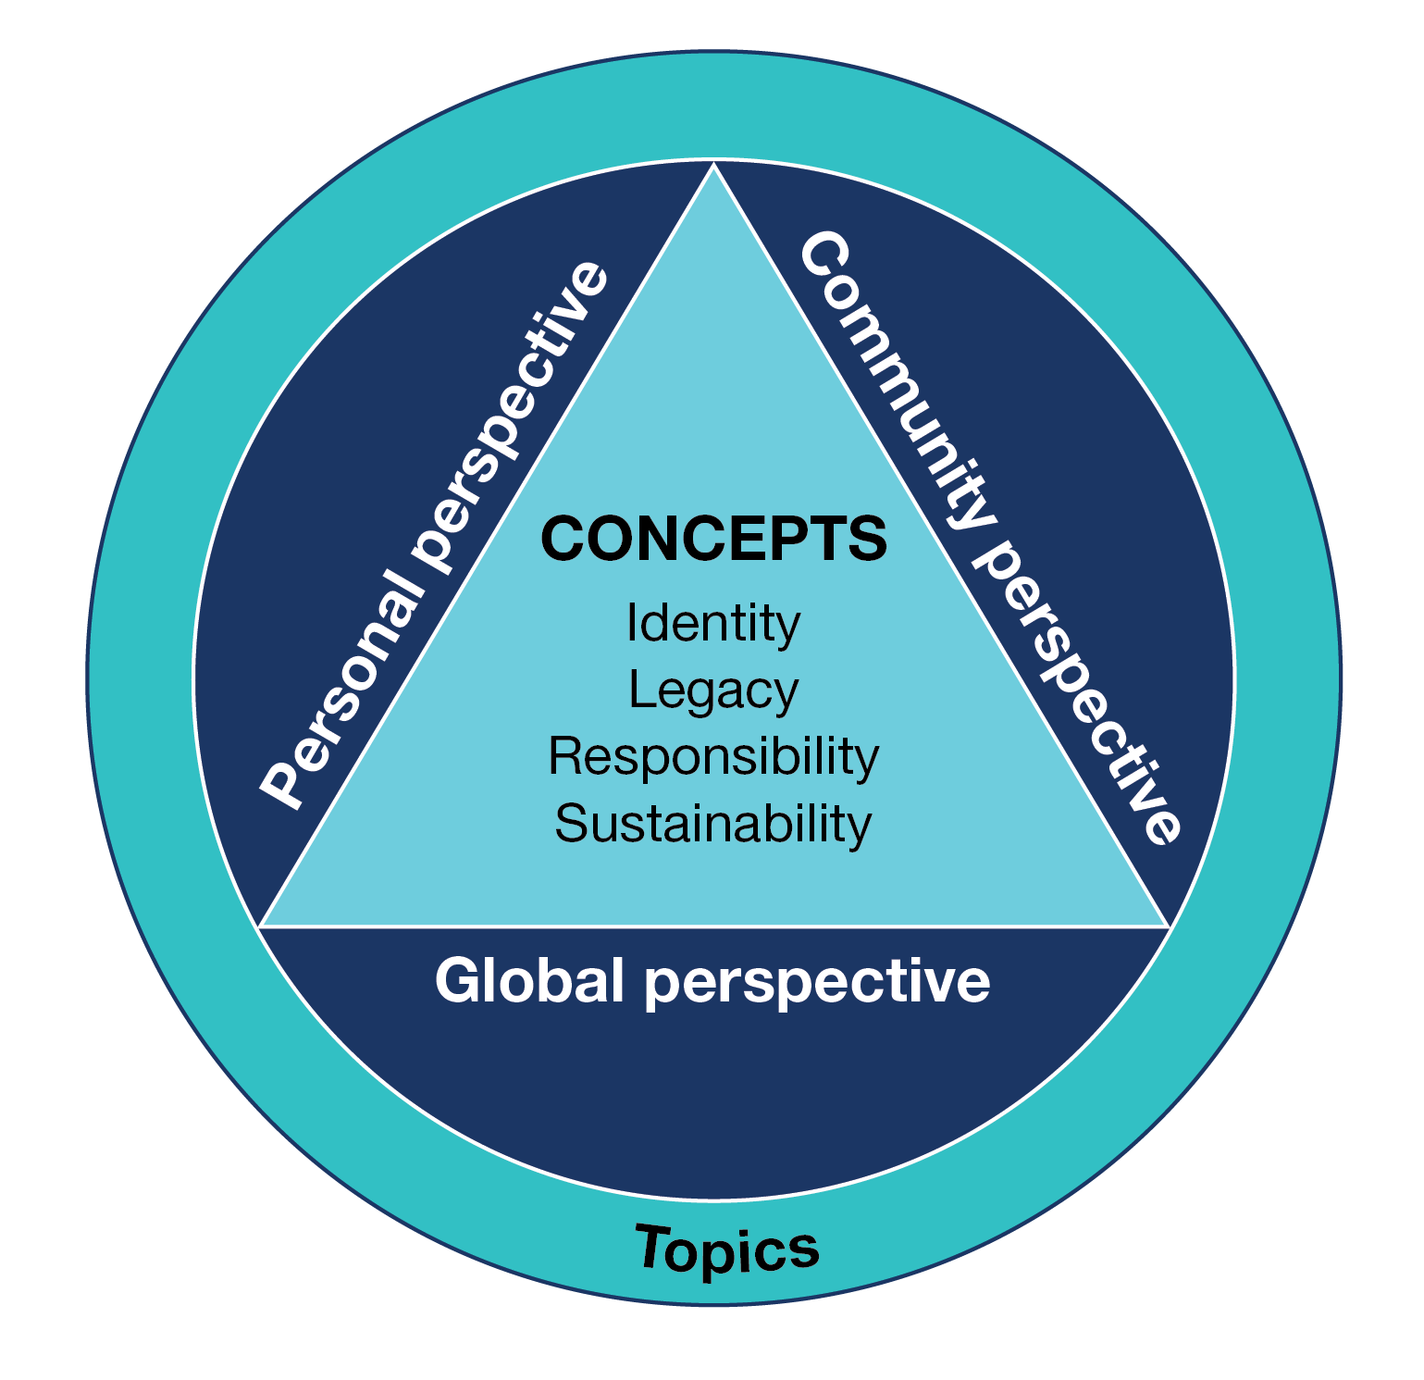

Concepts
The concepts provide the content that students are expected to encounter through the prescribed topics. The concepts are Identity, Legacy, Responsibility and Sustainability. They allow personal, community and global perspectives to be explored in Romanian and within the Australian context for language learning.
All concepts are to be studied over the two years of the senior secondary study of Romanian.

Identity
Studying the concept of Identity enables students to explore topics related to their personal world, for example, a sense of self, personal values, opinions, ideas, aspirations and relationships with others. It provides opportunities to reflect on personal identity, individuality and group affiliation in more than one language and cultural context. It enables students to explore and communicate aspects of Australian society in culturally and linguistically appropriate ways.

Legacy
Studying the concept of Legacy allows students to consider how people and events influence change, and how people respond to opportunities and challenges. They investigate topics related to the contributions, achievements and influence of Romanian-speaking individuals and communities throughout history and through to the present day. Students consider the impact and enduring nature of achievements on Romanian-speaking societies and beyond.

Responsibility
Studying the concept of Responsibility enables students to investigate how people manage social responsibilities and influence decisions that affect individuals or groups within society. The topics associated with this concept allow students to consider issues of particular relevance to young people and other groups within Romanian-speaking communities and to make comparisons with their own experiences.

Sustainability
Studying the concept of Sustainability provides students with the opportunity to explore topics with a focus on an aspect of sustainability, including present and future lifestyles, the environment and how language and culture can be sustained.

Perspectives
Students engage with the concepts through a range of prescribed topics that allow them to recognise, exchange and share ideas viewed from different personal, community and global perspectives.
All three perspectives are to be addressed through a range of topics over the two years of the study of Romanian at senior secondary level.

Topics
There are eight prescribed topics, all of which relate to the concepts and may be studied from a personal, community or global perspective. All topics are to be studied in the two years of the senior secondary study of Romanian. The topics provide the content focus for teaching, learning and assessment. The topics are taught through subtopics chosen by the teacher. Subtopics are not prescribed and allow flexibility in the way topics are taught and studied.
Through topics and tasks, students are provided with opportunities to apply key language skills, knowledge and understanding in authentic contexts and engage with content that reflects their interests and the requirements of the senior secondary study of Romanian.

Topics for Romanian for each concept

Identity
- Inclusivity, diversity and belonging
- Living in Australia

Legacy
- Innovation
- History and traditions

Responsibility
- Society
- Youth

Sustainability
- Sustaining language and culture
- Global trends

Selecting subtopics
The topics are taught through subtopics chosen by the teacher. When selecting subtopics over the two years of study, the teacher should ensure that students are provided with opportunities to engage with:
- each of the eight topics for the language
- personal, community and global perspectives
- content that has an Australian focus.
The following example shows how aspects of one of the prescribed topics may be developed for teaching and learning and may address different perspectives.
Concept: Legacy
Topic: Innovation
Example subtopic and perspective:
- Innovations I can’t live without (personal perspective)
OR
- Meeting the challenges of living in the 21st century through innovation and invention (community perspective)
OR
- Innovations that changed the world (global perspective)
For more examples of subtopics that align to the concepts and topics, refer to ‘Ideas for subtopics’ in the Support materials provided for this study.

Task design
Students will be provided with information about the context, purpose and audience for each school-based assessment task. In the written examination, appropriate information will be provided for all productive tasks.
Concepts, topics and perspectives are prescribed and create a framework of subject content for the activities and tasks that students undertake to demonstrate achievement of the outcomes of each unit. Language learning suited to the level and scope of the concepts, topics and perspectives is also specified and includes grammar, text types and writing styles that students are expected to be familiar with by the end of Unit 4. There is no prescribed order in which this learning should occur.
The Support materials provide further description of these language learning and language use requirements.

Tasks
Tasks are broadly defined as opportunities for the meaningful use of language and are designed to allow students to develop and demonstrate key skills, knowledge and understanding in Romanian at increasingly complex levels. They relate to the areas of study, which are based on the objectives of the CCAFL Framework – interacting in, analysing and creating meaning in language.
Three elements are to be specified for each task: context, purpose and audience.

Context
The context for communication requires students to consider suitable language for a particular situation. The context may be real, simulated or imaginary. Knowledge of the language as a system and the relationship between language and culture will inform the language used in any given context.

Purpose
The purpose indicates the reason for undertaking the task and the aims for communication in a particular context. Students demonstrate key skills, knowledge and understanding, and control of Romanian they have learned, by selecting and using appropriate and relevant language within the scope of the task.

Audience
The audience is the intended group of readers, listeners or viewers for the task. Students adjust their language to suit the audience for the task by considering aspects of language and culture that impact on developing shared meaning appropriate for that audience.

Terms used in the study

Authentic
‘Authentic’ is used to refer to contexts and learning experiences that allow students to use appropriate language for a given real-life situation.

CCAFL
The Collaborative Curriculum and Assessment Framework for Languages (CCAFL) project is an initiative of the Australasian Curriculum, Assessment and Certification Authorities (ACACA). It is a long-running national collaborative curriculum and assessment model that supports the provision of high quality languages education at the senior secondary level. It provides a common framework for the development of language curriculum and external assessment that ensures the ongoing provision of languages that might otherwise be unsustainable due to small candidatures.

CCAFL Framework (2021)
The CCAFL Framework provides the structure and elements that are common to all Australian CCAFL Languages developed at this level. It represents the foundation for the development of language-specific materials and state-based curriculum and assessment for these CCAFL Languages.

Creating meaning in Romanian
‘Creating meaning in Romanian’ refers to any language that students generate themselves in spoken, visual or written form. When creating meaning in Romanian, students present information, experiences, opinions and ideas through a range of interactions, text types, styles of writing and media. Creating meaning in Romanian is not limited to particular contexts, purposes or audiences, and includes language for all student products.

Intercultural competence
‘Intercultural competence’ is the ability to think, behave and create meaning to communicate effectively with people across cultures.

Mediating
‘Mediating’ between languages refers to an understanding of what is required to take meaning expressed in one language and create similar meaning in another language. Students need to consider aspects of language and culture that help or deflect shared understanding, and account for these in effective communication.

Self-representation
‘Self-representation’ refers to how students present themselves to others when using Romanian.

Visual texts
‘Visual texts’ are defined as texts that communicate information in visual form and do not rely on verbal information to convey meaning. For the purposes of this study, a visual text is defined as a visual image without text.
Visual texts include a wide range of texts, such as films, cartoons, photographs, posters, artworks, maps and many more. Care must be taken when selecting visual texts for school-based assessment tasks to ensure that the information required in the student response is located in the visual aspects of the text. Maps, charts and graphs with extensive written information may not be suitable as visual texts in this context.
Where very small quantities of incidental written text do appear, the visual image may be used on the condition that the written text does not convey meaning. If the image still conveys the intended message when the visual elements are removed and only the written text remains, the image is inappropriate as a visual text.

Unit 1
This unit focuses on the prescribed topics related to the concepts of Identity and Sustainability. Students develop the knowledge, skills and understanding to use language through subtopics that allow them to consider aspects of the topics from personal, community and global perspectives. Language learning supports language use associated with this focus.
The study specifications common to Units 1–4 are detailed in the ‘Study specifications’ section of this study design.

Area of Study 1

Interacting in Romanian
This area of study enables students to demonstrate their knowledge and skills in Romanian in culturally and linguistically appropriate ways.
Students exchange information, opinions, ideas and experiences in an informal, personal spoken interaction in Romanian, reflecting an aspect of the subtopic for this area of study.

Outcome 1
On completion of this unit the student should be able to exchange meaning in an informal, personal spoken interaction in Romanian.
To achieve this outcome the student will apply key knowledge and key skills outlined in Area of Study 1.

Key knowledge
- information and ideas related to the subtopic studied
- vocabulary and grammar suitable for exchanging information on the subtopic
- understanding of how to interact with others appropriately, in accordance with the role they are fulfilling
- oral language for participating in an informal, personal spoken interaction in Romanian, including idioms
- language and behaviours required to effectively initiate, maintain and close a spoken exchange

Key skills
- discuss the subtopic in a spoken exchange
- recognise and respond to cues for turn-taking
- self-correct language, as appropriate
- use appropriate pronunciation, intonation, stress and tempo
- use language that conveys intended meaning, taking into account cultural perspectives
- link and sequence ideas and information
- use a range of question-and-answer forms
- use appropriate forms of address and non-verbal forms of communication, such as eye contact and gestures
- interact with others appropriately in accordance with the roles of the participants in the spoken interaction, depending on age, status and other relevant considerations
- recognise meaning in expressions without a direct equivalent in English

Area of Study 2

Analysing Romanian
This area of study enables students to demonstrate the skills and knowledge used to analyse and respond in written English to texts presented in Romanian.
Students identify relevant content and interpret information, opinions or ideas from two texts related to different aspects of one subtopic. One text is a listening text and the other is a reading text. A visual text may also be provided to support the reading text. (Information on selecting visual texts is provided in the ‘Terms used in the study’ section of this study design.)
Students consider the features of the texts and cultural and intercultural considerations when comprehending meaning. They answer short-answer questions that relate to ideas presented in each text individually and the texts in combination and which may include comparisons.

Outcome 2
On completion of this unit the student should be able to analyse information from texts in Romanian related to different aspects of the subtopic studied and respond in writing to short-answer questions about the texts in English.
To achieve this outcome the student will apply key knowledge and key skills outlined in Area of Study 2.

Key knowledge
- ideas and concepts related to the subtopic studied
- conventions of the text types presented in the texts
- linguistic, cultural and intercultural considerations required to understand the texts
- vocabulary and grammar appropriate for understanding and analysing information on the subtopic

Key skills
- identify key concepts from the listening text and from the reading text (which may be supported by a visual text) in Romanian
- express gist and global understanding of meaning as well as specific details
- link ideas and information from various parts of the texts and from all the texts provided, which may include comparisons
- recognise and interpret expressions without a direct equivalent in English

Area of Study 3

Creating meaning in Romanian
This area of study enables students to demonstrate the skills and knowledge to write in Romanian for a specific context, purpose and audience.
The writing is related to the subtopic that has been studied in class and researched individually, in groups or as a class. Any research undertaken is intended to support students to create informed writing. Sources of information may be in Romanian, in English or another language, or a combination of these.
Students use language suited to the purpose, text type and writing style required in the response. They demonstrate an awareness of language as a system and cultural factors that influence meaning, in addition to using strategies for effective communication and self-representation.
Information on developing tasks is provided in the ‘Task design’ section of this study design. Further information is provided in the ‘Language and culture’ and ‘Language as a system’ sections.

Outcome 3
On completion of this unit the student should be able to produce original writing in Romanian on the subtopic studied that includes information to support ideas and opinions.
To achieve this outcome the student will apply key knowledge and key skills outlined in Area of Study 3.

Key knowledge
- ideas and concepts related to the subtopic studied
- language, including vocabulary and grammar, suitable for expressing information on the subtopic
- cultural and intercultural considerations relating to the subtopic
- conventions of text types and writing styles for the context, purpose and audience of the task
- language for producing information in writing suited to the task

Key skills
- use strategies for creating an original text in Romanian, such as planning, drafting, self-correcting and using dictionaries
- use a range of appropriate vocabulary, grammar and expressions suited to the subtopic and task
- sequence ideas logically
- engage the audience
- use suitable written language and any other elements appropriate to the text type, context, purpose and audience for the task
- use stylistic features suitable to the text type and writing style
- use appropriate spelling and punctuation
- review and correct written language, as appropriate

Assessment
The award of satisfactory completion for a unit is based on whether the student has demonstrated the set of outcomes specified for the unit. Teachers should use a variety of learning activities and assessment tasks that provide a range of opportunities for students to demonstrate the key knowledge and key skills in the outcomes.
The areas of study, including the key knowledge and key skills listed for the outcomes, should be used for course design and the development of learning activities and assessment tasks. Assessment must be a part of the regular teaching and learning program and should be completed mainly in class and within a limited timeframe.
All assessments at Units 1 and 2 are school-based. Procedures for assessment of levels of achievement in Units 1 and 2 are a matter for school decision.
For this unit students are required to demonstrate three outcomes. As a set these outcomes encompass the areas of study in the unit.
One task for each area of study is to be set for assessment in this unit. The following are examples of suitable tasks.

Outcome 1
- Participate in a conversation, interview or role-play related to identity, from a personal perspective
- Give a talk to the class about a subtopic related to sustainability (such as the preservation of languages from a global perspective), asking and responding to questions
- Participate in a discussion with the teacher on an aspect of a subtopic related to identity, viewed from a community perspective

Outcome 2
- Listen to a conversation and read a short article about an aspect of sustainability, and answer questions
- Read a journal entry and listen to an announcement that reflect personal views on identity, and respond to questions
- Answer a series of short-answer questions after hearing a podcast and reading a review on an aspect of sustainability in the community

Outcome 3
- Produce a written presentation, which may include visual elements, on a subtopic related to sustainability or identity
- Write a blog post encouraging emerging writers to share their views on identity in Australia
- Produce an annotated brochure that highlights places or activities of cultural interest related to community identity
Where teachers allow students to choose between tasks, they must ensure that the tasks they set are of comparable scope and demand.

Unit 2
This unit focuses on the prescribed topics related to the concepts of Legacy and Responsibility. Students develop the knowledge, skills and understanding to use language through subtopics that allow them to consider aspects of the topics from personal, community and global perspectives. Language learning will support language use associated with this focus.
The study specifications common to Units 1–4 are detailed in the ‘Study specifications’ section of this study design.

Area of Study 1

Interacting in Romanian
This area of study enables students to demonstrate their knowledge and skills in Romanian and their understanding of the influence of culture on language through extending an interaction in writing in Romanian.
Students respond in writing in Romanian to ideas, opinions and information presented in a listening text in Romanian on the subtopic studied. They consider strategies to engage with and extend the exchange in a written response.

Outcome 1
On completion of this unit the student will engage with the ideas, opinions and/or information raised in a listening text in Romanian and develop the exchange through an extended response in writing in Romanian.
To achieve this outcome the student will apply key knowledge and key skills outlined in Area of Study 1.

Key knowledge
- information and ideas related to the texts studied
- conventions of text types and language for producing information in writing for the context, purpose and audience of a task
- vocabulary and grammar suitable for understanding and expressing general and specific information on the subtopic

Key skills
- develop and respond to ideas, opinions and/or information represented in a text
- use strategies to identify, engage with and extend information from a text in a written response
- meet the requirements of the task, selecting and using relevant information
- express gist and global understanding of meaning as well as items of specific detail
- link and sequence ideas in writing

Area of Study 2

Analysing Romanian
This area of study enables students to demonstrate skills and knowledge to analyse and respond to a text presented in Romanian.
Students extract and interpret information, opinions and/or ideas from a reading text related to the subtopic studied. They consider the features of the text, aspects of language, and cultural and intercultural factors when locating meaning and expressing themselves in Romanian.
Students produce a written response in Romanian that presents relevant information from the reading text for a specified context, purpose and audience. The writing style, text type, context, purpose and audience for the response is different from those of the reading text.
Information about developing tasks is provided in the ‘Task design’ section of this study design.

Outcome 2
On completion of this unit the student should be able to produce writing in Romanian for a specified purpose and audience, using relevant information from a reading text in Romanian.
To achieve this outcome the student will apply key knowledge and key skills outlined in Area of Study 2.

Key knowledge
- information and ideas related to the subtopic studied
- vocabulary and grammar suitable for understanding, analysing and expressing information related to the subtopic and for the task
- knowledge of cultural and intercultural considerations associated with the subtopic and presented in the text
- knowledge of language for commenting in writing on information, ideas and opinions on the subtopic
- conventions of the text types associated with the task

Key skills
- identify and adapt key concepts from the reading text in the response in Romanian
- recognise meaning in expressions from the reading text without a direct equivalent in English
- express gist and global understanding of meaning as well as items of specific detail
- reorganise and link information in response to the requirements of the task
- use appropriate language for the purposes of the text type and audience of the task, such as a suitable level of formality
- use suitable grammar, vocabulary, spelling and punctuation
- review and correct written language, as required

Area of Study 3

Creating meaning in Romanian
This area of study enables students to demonstrate the skills and knowledge to create a spoken presentation in Romanian for a specific context, purpose and audience. The spoken presentation is related to a subtopic with a focus on Australia.
The spoken presentation may address an aspect of society, an individual or a group, or it may explore comparisons between Australia and other countries. Students demonstrate an awareness of cultural factors that influence meaning to accurately express general and detailed aspects of the subtopic in a way that is meaningful to Romanian-speakers. Students use language suited to the context, purpose, audience and text type required in the response. They use strategies for effective communication, for positive self-representation and to create interest for the audience.

Outcome 3
On completion of this unit the student should be able to deliver a spoken presentation in Romanian that accurately expresses meaning to Romanian-speakers on the subtopic related to Australia that has been studied.
To achieve this outcome the student will apply key knowledge and key skills outlined in Area of Study 3.

Key knowledge
- understanding of one or more aspects of Australian society
- information and ideas that reflect the subtopic studied
- vocabulary and grammar appropriate for understanding, analysing and expressing information in the spoken presentation
- cultural and intercultural considerations relating to the subtopic studied
- text and language conventions used in spoken Romanian
- focus and purpose suited to the subtopic and audience

Key skills
- explain an aspect of the subtopic related to Australia through an original spoken presentation
- use spoken language and strategies appropriate to the text type, purpose and audience for the presentation
- use a range of appropriate grammar and vocabulary for the task and audience
- use a suitable level of formality for the task and audience
- use appropriate pronunciation, intonation, stress and tempo
- select relevant examples to present an aspect of Australian society
- sequence ideas logically
- create interest for the audience through the presentation
- use visual materials, digital media or other resources to support the presentation, as appropriate
- review and correct language in preparation for the presentation

Assessment
The award of satisfactory completion for a unit is based on whether the student has demonstrated the set of outcomes specified for the unit. Teachers should use a variety of learning activities and assessment tasks that provide a range of opportunities for students to demonstrate the key knowledge and key skills in the outcomes.
The areas of study, including the key knowledge and key skills listed for the outcomes, should be used for course design and the development of learning activities and assessment tasks. Assessment must be a part of the regular teaching and learning program and should be completed mainly in class and within a limited timeframe.
All assessments at Units 1 and 2 are school-based. Procedures for assessment of levels of achievement in Units 1 and 2 are a matter for school decision.
For this unit students are required to demonstrate three outcomes. As a set these outcomes encompass the areas of study in the unit.
One task for each area of study is to be selected for assessment in this unit. The following are examples of suitable tasks.

Outcome 1
- Listen to a radio program or podcast, then write an email to the producer to find out more about one of the famous people presented in the program
- Listen to a telephone message about arrangements for an event your class is organising to raise awareness of a social issue in the community, noting the main items your class will need to address
- Listen to a presentation on an aspect of the history in a country where Romanian is spoken and write a letter to the guest speaker thanking them and explaining why the presentation was of interest

Outcome 2
- Read an article from a community newsletter about a traditional cultural event that is still practised and write an informative review explaining its relevance today
- Read about youth attitudes to combining part-time work and study and write an opinion piece about your views on the issues
- Read a text about a special cultural tradition found only at a particular travel destination and write an email to convince your friend to join you on a trip there

Outcome 3
- Narrate a life story, tradition, activity, event or incident that highlights an aspect of Australian history or contemporary society
- Tell the class about the achievements of a person from a Romanian-speaking community and their contribution to Australian life; for example, an actor, sportsperson, poet, influencer, scientist or teacher
- Present a personal reflection on the influence of traditional dishes on Australian cuisine
Where teachers allow students to choose between tasks they must ensure that the tasks they set are of comparable scope and demand.

Unit 3
Across Units 3 and 4 students will study topics related to all the concepts of the study – Identity, Legacy, Responsibility and Sustainability – through the subtopics selected for each unit.
This unit focuses on language use related to three or more subtopics, each of which is chosen to allow students to consider aspects of the prescribed topics. The subtopics studied may focus on one or more perspectives and will engage students with personal, community and global perspectives across Units 3 and 4.
The study specifications common to Units 1–4 are detailed in the ‘Study specifications’ section of this study design.

Area of Study 1

Interacting in Romanian
This area of study enables students to develop their knowledge and skills in Romanian and reflect on the relationship between language and culture by participating in a spoken exchange to negotiate a future action.
Students exchange information, opinions, ideas and/or experiences and negotiate future action relating to the subtopic studied in a spoken interaction in Romanian. They do this by playing an agreed role, mindful of aspects of language and culture that influence the role, meaning expressed and the effectiveness of the agreement they achieve.

Outcome 1
On completion of this unit the student should be able to participate in a spoken role-play in Romanian to negotiate an agreed future action related to an aspect of the subtopic studied.
To achieve this outcome the student will apply key knowledge and key skills outlined in Area of Study 1.

Key knowledge
- information and ideas related to the subtopic studied
- cultural and intercultural considerations relating to the subtopic
- vocabulary and grammar suitable for expressing opinions and negotiating
- spoken language and behaviours required to effectively initiate, maintain and close a spoken exchange
- register appropriate to the audience

Key skills
- use appropriate pronunciation, intonation, stress and tempo
- use appropriate register to address others
- use suitable non-verbal forms of communication
- review and correct language during the spoken exchange, as appropriate
- exchange relevant information and justify opinions and ideas
- recognise meaning in expressions without a direct equivalent in English
- link ideas logically
- use language that expresses the intended meaning, accounting for cultural perspectives
- accommodate expectations and influences that impact on participants in the interaction
- use negotiation strategies
- clarify decisions and ensure future actions are agreed

Area of Study 2

Analysing Romanian
This area of study enables students to develop skills and knowledge to analyse and respond in Romanian to texts presented in Romanian.
Students identify relevant content and interpret information, opinions and/or ideas from two reading texts related to different aspects of one subtopic studied. A visual image without text may also be provided with the reading texts.
Students consider the features of the texts and cultural and intercultural considerations when seeking and relaying meaning. They answer questions that relate to ideas presented in each text individually and the texts in combination and which may include comparisons.

Outcome 2
On completion of this unit the student should be able to analyse and synthesise information from texts in Romanian related to different aspects of the subtopic studied and respond to short-answer questions about the texts in Romanian.
To achieve this outcome the student will apply key knowledge and key skills outlined in Area of Study 2.

Key knowledge

- information and ideas related to the subtopic studied
- vocabulary and grammar suitable for understanding, analysing and expressing information on the subtopic
- conventions of text types in reading texts

Key skills
- summarise and synthesise information and ideas from texts in Romanian
- recognise the intentions, attitudes and perspectives of the authors of the texts
- use a selection of material from the texts to answer specific questions
- identify gist, main points, supporting points and details from the texts
- recognise meaning in expressions without a direct equivalent in English
- respond clearly to questions using relevant information
- express meaning accurately and appropriately in writing in Romanian
- use appropriate grammar, spelling and punctuation in the responses in Romanian
- review and correct language, as appropriate

Area of Study 3

Creating meaning in Romanian
This area of study enables students to develop the skills and knowledge to write in Romanian for a specific context, purpose and audience.
Student writing is related to the subtopic studied and researched either individually, in groups or as a class. Any research undertaken supports students to create informed writing. Sources of information may be in Romanian, in English or another language, or a combination of these.
Students use language suited to the purpose, text type and writing style required by the task. The written response is descriptive, informative or personal writing, or a combination of these writing styles.
Students demonstrate an awareness of language as a system and cultural factors that influence meaning, in addition to using strategies for effective communication and self-representation.

Outcome 3
On completion of this unit the student should be able to write in Romanian for a specific context, purpose and audience, using appropriate text features and information to support ideas and opinions.
To achieve this outcome the student will apply key knowledge and key skills outlined in Area of Study 3.

Key knowledge
- features of a range of written texts
- vocabulary and grammar suitable for expressing personal ideas and presenting information
- language conventions suited to the text type required in response to the task
- appropriate register for the different purposes, contexts and audiences of texts and responses
- sources of reference materials to support writing

Key skills
- use strategies for producing original writing in Romanian
- sequence ideas appropriately and in accordance with the features of the text type
- use stylistic features, conventions and other elements appropriate to the writing style, text type, purpose, context and audience
- use language that expresses intended meaning, accounting for cultural and intercultural considerations
- vary language for the purpose, context and audience of the task
- use appropriate style and register
- engage the audience
- use appropriate spelling, punctuation and a range of grammar
- select and make appropriate use of reference materials, including dictionaries
- review and correct written language, as required

School-based assessment

Satisfactory completion
The award of satisfactory completion for a unit is based on whether the student has demonstrated the set of outcomes specified for the unit. Teachers should use a variety of learning activities and assessment tasks to provide a range of opportunities for students to demonstrate the key knowledge and key skills in the outcomes.
The areas of study and key knowledge and key skills listed for the outcomes should be used for course design and the development of learning activities and assessment tasks.

Assessment of levels of achievement
The student’s level of achievement in Unit 3 will be determined by School-assessed Coursework. School-assessed Coursework tasks must be a part of the regular teaching and learning program and must not unduly add to the workload associated with that program. They must be completed mainly in class and within a limited timeframe.
Where teachers provide a range of options for the same School-assessed Coursework task, they should ensure that the options are of comparable scope and demand.
The types and range of forms of School-assessed Coursework for the outcomes are prescribed within the study design. The VCAA publishes Support materials for this study, which includes advice on the design of assessment tasks and the assessment of student work for a level of achievement.
Teachers will provide to the VCAA a numerical score representing an assessment of the student’s level of achievement. The score must be based on the teacher’s assessment of the performance of each student on the tasks set out in the following table.

Contribution to final assessment
School-assessed Coursework for Unit 3 will contribute 25 per cent to the study score.
Outcomes | Marks allocated | Assessment tasks
Outcome 1  Participate in a spoken role-play in Romanian to negotiate an agreed future action | 20 | Three- to four-minute role-play in Romanian focusing on a negotiated future action
Outcome 2  Analyse and synthesise information from texts in Romanian related to different aspects of the subtopic | 15 | Responses in Romanian to specific short-answer questions using information extracted from written texts related to a selected topic. A visual text may be included
Outcome 3  Write in Romanian for a specific context, purpose and audience | 15 | Approximately 250-word piece of writing in Romanian suited to the context, text type and writing style (descriptive, informative or personal) required in the response
Total marks | 50

External assessment
The level of achievement for Units 3 and 4 is also assessed by an end-of-year examination (see page 44), which will contribute 50 per cent to the study score.

Unit 4
Across Units 3 and 4 students will study topics related to all the concepts of the study – Identity, Legacy, Responsibility and Sustainability – through the subtopics selected for each unit.
This unit focuses on language use related to three or more subtopics, each of which is chosen to allow students to consider aspects of the prescribed topics. The subtopics studied may focus on one or more perspectives and will engage students with personal, community and global perspectives across Units 3 and 4.
The study specifications common to Units 1–4 are detailed in the ‘Study specifications’ section of this study design.

Area of Study 1

Interacting in Romanian
This area of study enables students to present information, opinions and ideas in spoken Romanian and discuss aspects of the subtopic studied.
Students express and present ideas, experiences, opinions and/or arguments related to the subtopic studied in a spoken presentation for a specified context, purpose and audience. Students then participate in a discussion related to the presentation.

Students consider aspects of language, culture and appropriateness of content when presenting to speakers of Romanian. To improve authentic language use and positive self-representation, students may choose to focus on a global perspective, Australian experience or a comparison, depending on the subtopic studied.

Outcome 1
On completion of this unit the student should be able to present information in a spoken presentation and participate in a discussion about the content of the presentation in Romanian.
To achieve this outcome the student will apply key knowledge and key skills outlined in Area of Study 1.

Key knowledge
- relevant information, ideas and opinions about the subtopic studied
- vocabulary and grammar suitable for expressing information, explaining opinions and sharing ideas
- spoken language and behaviours required to present information and participate in a discussion on an aspect of the subtopic
- appropriate techniques for exchanging information and ideas with an adult interlocutor
- ways of responding in spoken Romanian to questions
- correct register appropriate to the task

Key skills
- speak to a particular point of view
- exchange, justify and elaborate ideas and opinions
- use appropriate pronunciation, intonation, stress and tempo
- review and correct language, as appropriate
- use appropriate register for the task and audience
- use suitable non-verbal forms of communication
- explain meaning in expressions without a direct equivalent in English
- use a range of vocabulary and structures, including some specialist terminology required by the subtopic studied
- select relevant and interesting information for the presentation and in response to questions
- select and use relevant reference materials, including dictionaries
- recognise and use suitable language and strategies to distinguish between factual and personal perspectives
- link ideas logically
- recognise and respond to cues for turn-taking

Area of Study 2

Analysing Romanian
This area of study enables students to analyse texts presented in Romanian and develop an extended response in Romanian.
Students identify relevant content and interpret information, opinions and/or ideas from two texts related to different aspects of the subtopic studied. One text is a reading text and the other is a listening text. A visual image without text may also be provided with the reading text.
Students respond in writing in Romanian, adapting relevant information from each of the texts. The written response requires a different text type, context, purpose and audience to those of the reading and listening texts. The task specifies one or more of the writing styles outlined in the study design to be addressed in a single response.

Outcome 2
On completion of this unit the student should be able to identify information from texts in Romanian related to different aspects of the subtopic studied and use relevant information to write an extended response for a specific context, purpose and audience in Romanian.
To achieve this outcome the student will apply key knowledge and key skills outlined in Area of Study 2.

Key knowledge
- information and ideas related to the subtopic studied
- vocabulary and grammar suitable for interpreting and expressing information about the subtopic
- awareness of different social contexts and the requirements of different text types
- features of text types
- language for analysing, synthesising and comparing ideas in extended writing

Key skills
- use strategies for identifying and understanding key ideas and detailed information from texts in Romanian
- identify similarities and differences between texts
- identify aspects of culture, language or context critical to meaning in the texts
- identify relationships between key ideas and perspectives expressed in the texts
- present information relevant to the purpose, context and audience of the task
- locate evidence to support particular views or interpretations of information from the texts
- use appropriate grammar, punctuation, spelling and text conventions
- use suitable stylistic features for the purpose, context, audience and text type required in the response
- review and correct language, as appropriate

Area of Study 3

Creating meaning in Romanian
This area of study enables students to develop the skills and knowledge to write in Romanian for a specific context, purpose and audience.
Students use language suited to the context, purpose, audience, text type and writing style specified for the response. The written response is evaluative, imaginative, persuasive or reflective writing, or a combination of these writing styles.
A visual image without text may be provided as stimulus.

Outcome 3
On completion of this unit the student should be able to produce an extended piece of original writing in Romanian in response to a task.
To achieve this outcome the student will apply key knowledge and key skills outlined in Area of Study 3.

Key knowledge
- information related to the subtopic studied

- vocabulary and grammar suitable for each of the writing styles
- conventions used in Romanian for each of the writing styles and relevant text types
- stylistic features appropriate to the text types and for a range of audiences

Key skills
- produce original writing in Romanian
- sequence ideas logically
- use appropriate grammar, spelling and punctuation
- use stylistic features, conventions and other elements appropriate to the writing style and text type of the response
- use suitable written language for the purpose, context and audience of the writing in the response
- accurately express intended meaning
- review and correct language, as appropriate

School-based assessment

Satisfactory completion
The award of satisfactory completion for a unit is based on whether the student has demonstrated the set of outcomes specified for the unit. Teachers should use a variety of learning activities and assessment tasks to provide a range of opportunities for students to demonstrate the key knowledge and key skills in the outcomes.
The areas of study and key knowledge and key skills listed for the outcomes should be used for course design and the development of learning activities and assessment tasks.

Assessment of levels of achievement
The student’s level of achievement in Unit 4 will be determined by School-assessed Coursework.
School-assessed Coursework tasks must be a part of the regular teaching and learning program and must not unduly add to the workload associated with that program. They must be completed mainly in class and within a limited timeframe.
Where teachers provide a range of options for the same School-assessed Coursework task, they should ensure that the options are of comparable scope and demand.
The types and range of forms of School-assessed Coursework for the outcomes are prescribed within the study design. The VCAA publishes Support materials for this study, which includes advice on the design of assessment tasks and the assessment of student work for a level of achievement.
Teachers will provide to the VCAA a numerical score representing an assessment of the student’s level of achievement. The score must be based on the teacher’s assessment of the performance of each student on the tasks set out in the following table.

Contribution to final assessment
School-assessed Coursework for Unit 4 will contribute 25 per cent to the study score.

Outcomes | Marks allocated | Assessment tasks
Outcome 1  Present information in a spoken presentation and participate in a discussion about the content of the presentation in Romanian | 20 | Four- to five-minute presentation and discussion in Romanian, including a presentation of up to 90 seconds
Outcome 2  Identify information from texts in Romanian related to different aspects of the subtopic studied and use relevant information to write an extended response | 15 | Approximately 250-word written response in Romanian, incorporating information from two or more texts
Outcome 3  Produce an extended piece of original writing in Romanian | 15 | Approximately 300-word piece of writing in Romanian, suited to the context, text type and writing style (evaluative, imaginative, persuasive or reflective) required in the response
Total marks | 50

External assessment
The level of achievement for Units 3 and 4 is also assessed by two end-of-year examinations.

Contribution to final assessment
The examinations together will contribute 50 per cent to the study score.

End-of-year examinations

Description
- Oral examination
- Written examination
All the key knowledge and key skills that underpin the outcomes in Units 3 and 4 are examinable.
The written examination will be set by a panel appointed by the agency that produces the examination.

Conditions
The examinations will be completed under the following conditions:
- Duration:
- Oral examination: approximately 15 minutes
- Written examination: 2 hours plus 10 minutes reading time
- Date:
- Oral examination: end-of-year, on a date set and published annually by the VCAA
- Written examination: end-of-year, on a date set annually by the Chief Executives of the Australasian Curriculum Assessment and Certification Authorities and published annually by the VCAA

- The oral examination will be marked by assessors appointed by the VCAA.
- The written examination will be marked by assessors appointed by the agency that produces the examination.
- In the written examination, a range of text types will be included in listening and reading texts. However, students are expected to produce only the written text types in Romanian listed in the ‘Text types’ section of this study design.
- VCAA examination rules will apply. Details of these rules are published annually in the VCE Administrative Handbook.

Further advice
The VCAA publishes specifications for all VCE examinations on the VCAA website. Examination specifications include details about the sections of the examination, their weighting, the question format(s) and any other essential information. The specifications are published in the first year of implementation of the revised Unit 3 and 4 sequence, together with any sample material.

